1. “Incorrect QR Code” is not aligned. It must be aligned with “Required”.

## 

1. In case of Pending Transaction, there can be an option to Edit and continue the pending transaction, since there is an option to Cancel Transaction. Not sure if this is how it works in Crypto.

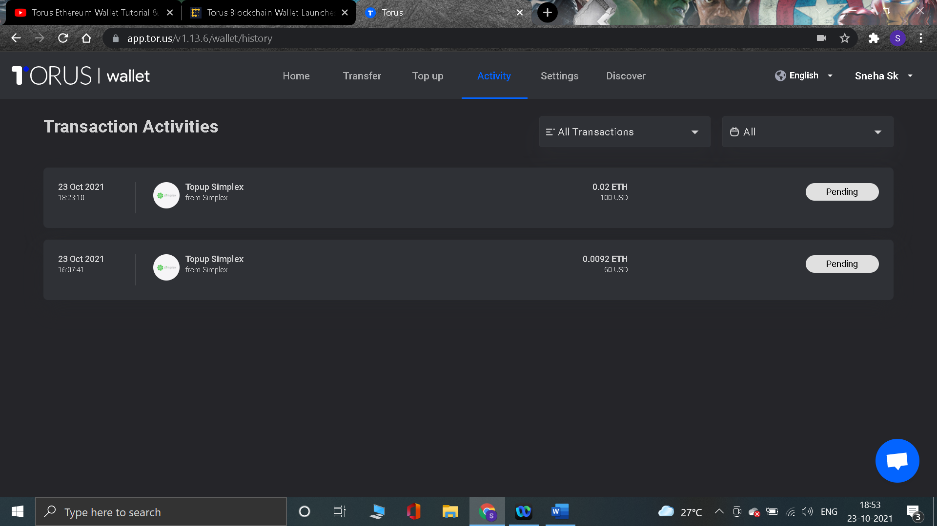

1. When a transaction is made, the activity section is updated after a while. Looks like its coming from the third party app, but can be faster enough.



1. The “Select Item” is a dropdown with just one item in it, it might not be a dropdown. In case there are more options to be added, then this should be okay.

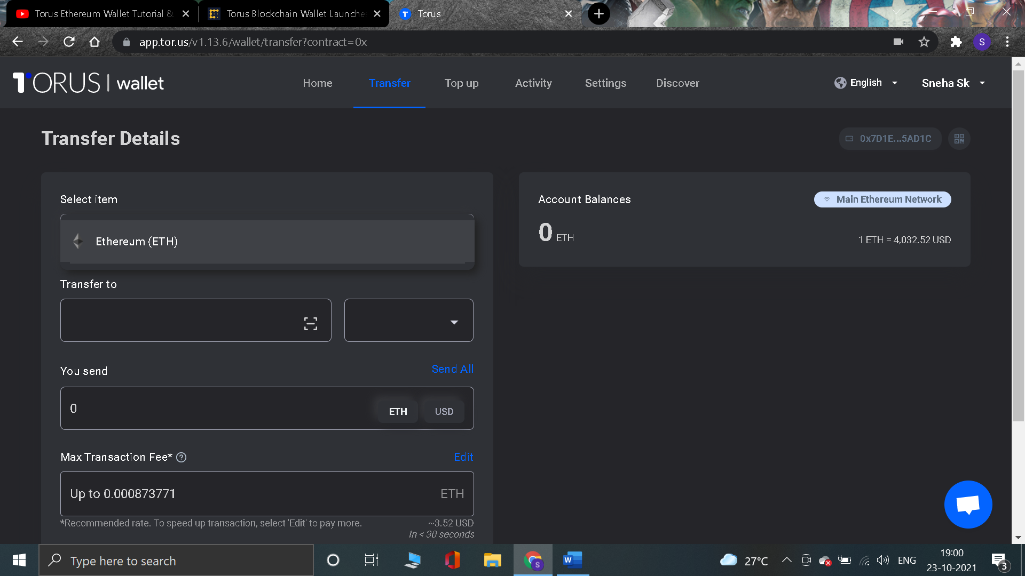

1. The right most indicator functionality is not clear on the mobile app for the users.

Note: I just learnt it, this is to scan QR code, which I am not sure how or what it did as nothing actually came up on the screen.

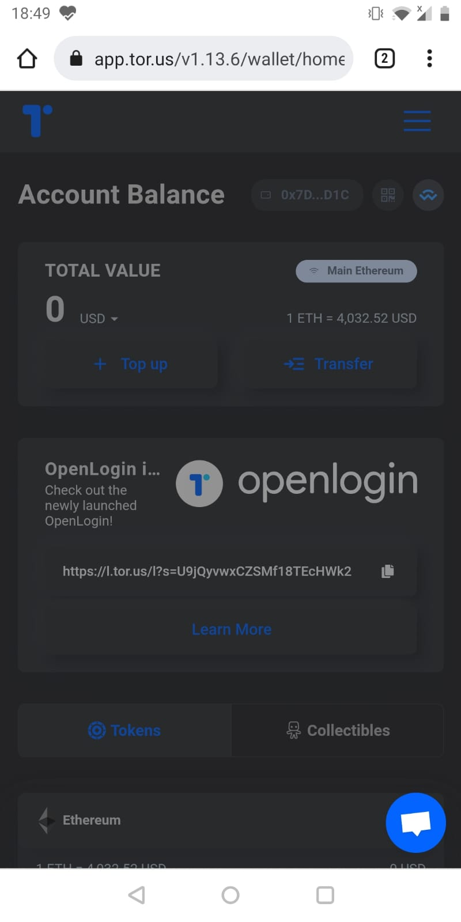

1. “OpenLogin” updates section can be on the right hand side section and not aligned with main functionality. As it is gaining more attention along with the main feature.

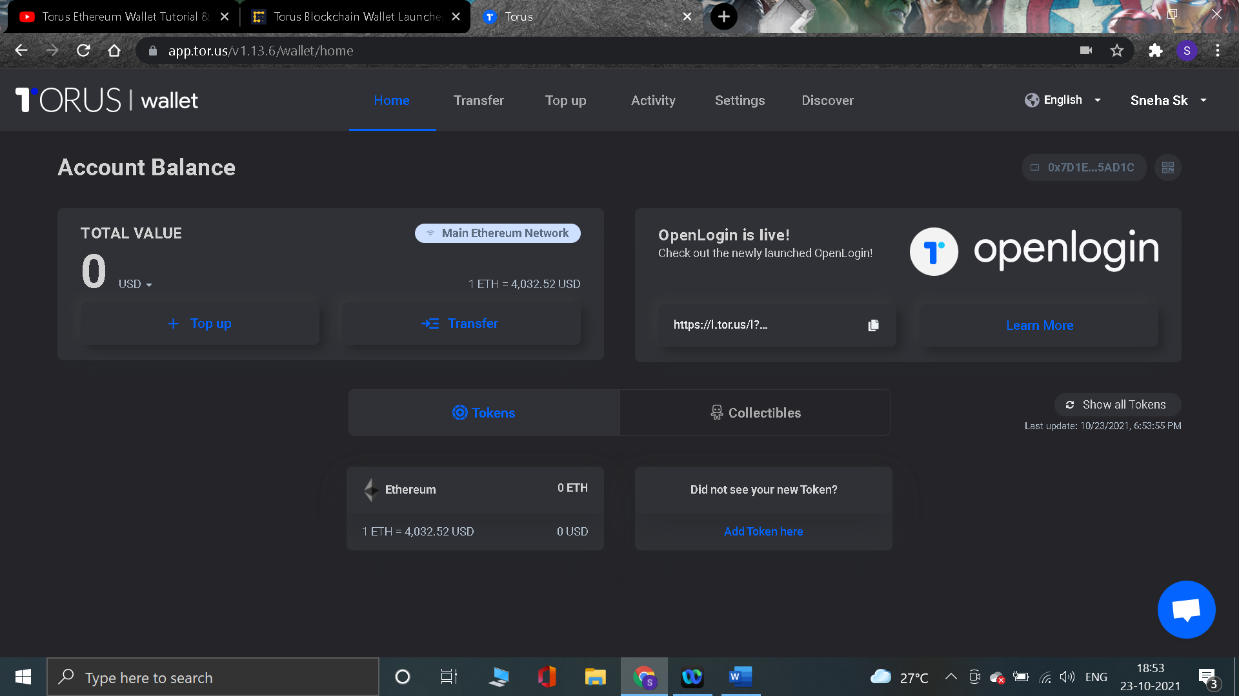

1. “OpenLogin” updates section can be on the bottom section and not aligned with main functionality. As it is gaining more attention along with the main feature.

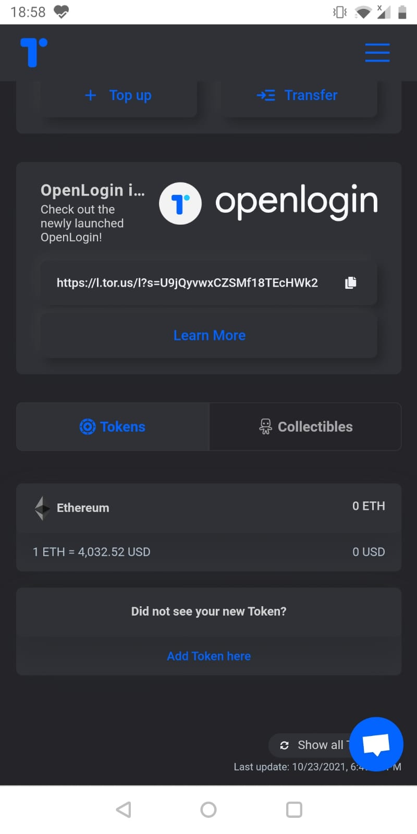

1. The Discover page is slower.

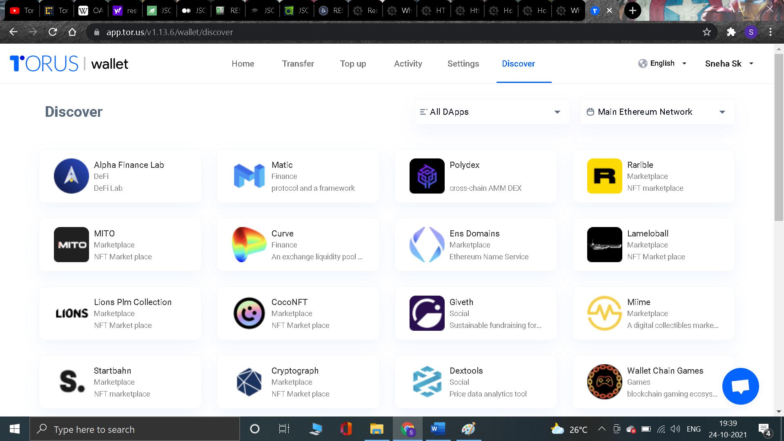

1. The background is too plain. We can have some prints/patterns or shades.
2. Enhancement can be the “Transfer” page can have trends (history in graphical form) of the Selected item to make better decision in choosing the network, in the Bottom Right empty space.

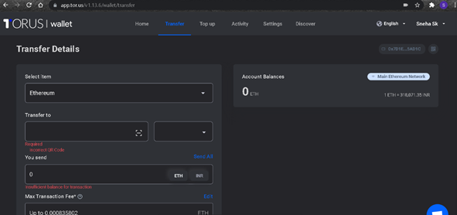

/******************************************************************************

Online Java Compiler.

Code, Compile, Run and Debug java program online.

Write your code in this editor and press "Run" button to execute it.

*******************************************************************************/

import java.util.*;

public class Main

{

public static void longestPalindrome(String str){

int count =0;

int max_count = 0;

String subString = "";

for(int i=0;i<str.length();i++) {

for(int j=i+1;j<str.length();j++) {

StringBuilder sb = new StringBuilder();

subString = str.substring(i,j);

sb.append(subString);

sb.reverse();

if(str.contains(sb)){

count = sb.length();

}

if(max_count<count) {

max_count= count;

}

}

}

System.out.println(max_count);

}

public static void main(String[] args) {

longestPalindrome("ac");

}

}